# **Year 13 Results Day Guide 2025.**

This guide is to support those who will be receiving their A level and other level 3 qualifications, including BTEC and T Level results on or by 14th August 2025.

There is information about university options and other alternatives, including apprenticeships.

* The date you receive A level and T Level grades is Thursday 14th August 2025.
* Other qualification results, including BTEC Level 3 will be released to students on or before 14th August 2025.
* The date to receive GCSE results is Thursday 21st August 2025.
* UCAS Clearing will be open for eligible students to make a Clearing Choice at 1pm on results day and will close on 20th October 2025. The Contact number for UCAS for (students) is 0371 468 0468 and you will need to have your 10 Digit UCAS Personal ID Number and 6 Digit Clearing Number ready.
* There is more information about examinations [here](https://www.gov.uk/government/publications/ofqual-student-guide-to-exams-and-assessments-in-2025) or go to

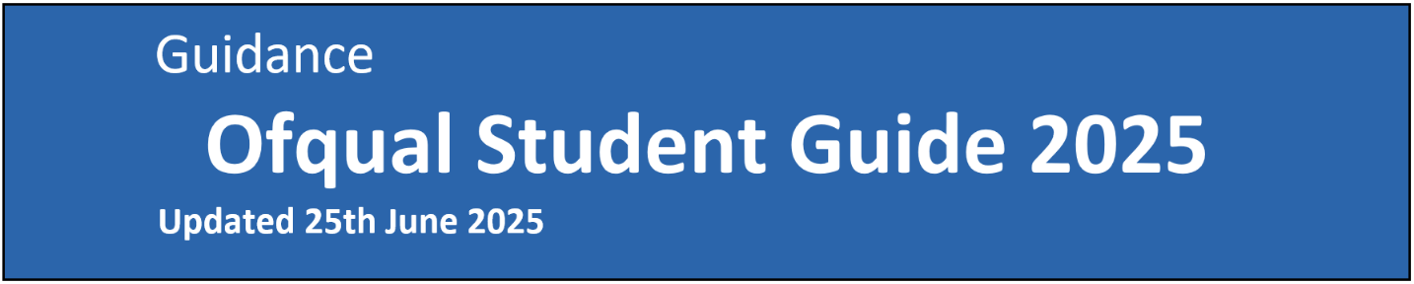<https://www.gov.uk/government/organisations/ofqual>

We will still be available to support you on results days and other days thereafter. Careers Advisers will be available in various sixth forms on A level/BTEC/CTEC/T Level results day and at all schools on GCSE results day in the morning. You can also come in and see us if you need advice on results days from 2pm – 4.30pm at [Young WorkPath, Idea Store, 260 Commercial Road, E1 2FB](https://www.ideastore.co.uk/visit-us/idea-store-watney-market) (near Shadwell DLR and Shadwell Overground Station). Alternatively, contact us Monday – Friday 9am-12pm and 1pm-5.00pm as we will also offer careers interviews over the phone or via Teams.

Telephone: 0207 364 1401 or 0800 3581 2410 (free phone)

Email: [youngworkpath@towerhamlets.gov.uk](mailto:youngworkpath@towerhamlets.gov.uk)

We expect to be very busy, so please do be patient if contacting us. There is also information on our webpage [Young WorkPath](http://www.towerhamlets.gov.uk/youngworkpath)

**What could you do after year 13?**

**The entry requirements can vary and often depend on the level.**

**What are the different options?**

**More information is** [**here**](https://www.towerhamlets.gov.uk/lgnl/jobs_and_careers/employment_and_training_initia/Workpath/Options_after_sixth_form_or_college.aspx) **or go to** [**Young WorkPath**](http://www.towerhamlets.gov.uk/youngworkpath) **and at the bottom of the page select ‘I’m a young person’ and then ‘options after sixth form or college’.**

**University:** full or part time, which can be from 3-6 years (typically 3). This requires a level 3 qualification, such as A levels/BTEC/T Level and often GCSEs (in Maths and English Language), and sometimes specific subject/s but depends on the course and the university.

**Apprenticeships (levels from 2-7):** a work, learn and earn option, where you are employed by a company to work 80% of the week (usually 4 days) and 20% studying (usually one day per week or in block release every few weeks) for a qualification relevant to your job and is paid for by the company. For higher/degree level apprenticeships (Level 4 to 7) you will need to be 18 and have a level 3 qualification. Apprenticeships last for a minimum of one year to 18 months (longer for higher level/degree apprenticeships).

**Employment (if with training this is sometimes called an ‘apprenticeship or school leaver/training programme’):** could be full or part- time working for a company in a variety of sectors and entry requirements can vary. If an apprenticeship or school/college training programme, you would work for a company most of the week and get training/qualification for that job.

**Update: *Supported Internship:** aSupported Internship is a 12-month supported work placement programme for young people (typically for those aged 18 to 24 with an EHCP). The supported internship usually provides the intern with insight into a company with the purpose of leading the intern into employment. Each Supported Internship will have its own specific criteria for the programme.

**Gap Year:** there can be different reasons for wanting to take a year out, but most people work, volunteer and/or travel. Some companies have specific gap year schemes which you would usually apply to before you finish year 13 and are only for that specific year, but sometimes those who take part can be offered a permanent job or may secure a job after university with the same company. Check for any travel restrictions. If you secure a university place for September 2025 and you want to defer your entry to the following year, you must get permission from the university first (in writing). Otherwise, you will need to apply to university again during your gap year. Please note there will be a new personal statement format for 2026 entry. For more information, click [**here**](https://www.ucas.com/applying/applying-to-university/writing-your-personal-statement/the-new-personal-statement-for-2026)or go to: [UCAS Writing your Personal Statement](https://www.ucas.com/applying/applying-to-university/writing-your-personal-statement/the-new-personal-statement-for-2026).

**NVQ (levels 1-7):** is another type of vocational qualification that involves training for a specific job, a work-based way of learning, which is carried out at a college, or workplace usually in conjunction with an employer. NVQs involve a range of on-the-job tasks and activities that are designed to test you on your ability to do a job effectively. They may also be studied as part of an apprenticeship.

**Programme:** there are various other programmes depending on circumstances and interests and what is available at the time. These could be short courses building up IT skills for example. These short programmes are a great addition to a CV/job application form.

**Volunteering:** a great way to understand a business, organisation or company, explore career area/s, develop skills and meet new people. It can also look great on your CV. Volunteering is also a positive stopgap in between jobs.

**Re-sits:** depending on your results you might be able to re-sit some subjects while working and/or studying.

**Questions about UCAS**

* [UCAS after you apply - access your application](https://www.ucas.com/undergraduate/after-you-apply/access-your-application) to see your deadline.

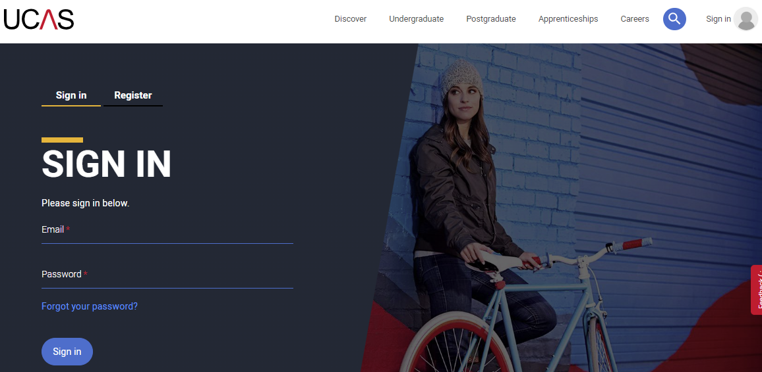

* **I have applied to start university in 2025 and replied to my offers, but I would like to defer to start next year in 2026:**

You will need to contact the university or college directly to discuss if this is possible and to check if that university will hold your place. Click [here](https://www.ucas.com/undergraduate/applying-university/when-apply/deferred-entry#:~:text=How%20to%20defer%20your%20application,choice%20on%20your%20UCAS%20application.) to read more information from UCAS or go to: [Deferring Entry](https://www.ucas.com/undergraduate/applying-university/when-apply/deferred-entry#:~:text=How%20to%20defer%20your%20application,choice%20on%20your%20UCAS%20application).

* **I have applied to university but not been given any offers – Clearing:**

Clearing is how universities and colleges fill places they still have on their courses and gives applicants without a place the opportunity to find a course. From 5 July – 20 October 2025, you can contact as many universities as you would like to check if a course of interest still has places. If you are in Clearing, your UCAS application will indicate this. You can search the UCAS website for Clearing vacancies or use Clearing Plus, (which is a facility for students in Clearing) that matches you to courses you may be interested in, using what UCAS knows about you from your application, and what universities and colleges are looking for, and you can still search for something different. Click [here](https://www.ucas.com/clearing-launch) for information or go to [UCAS Clearing Launch](https://www.ucas.com/clearing-launch).

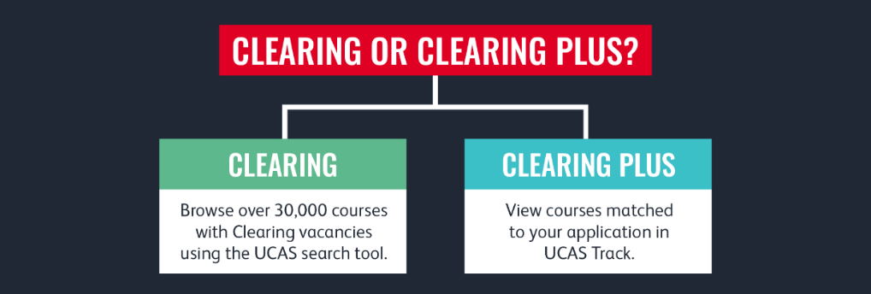

# **Results day**

# A group of young people talking

* **I did not get the grades I wanted:**

Hopefully, you can still progress onto your next step - Contact universities to find out or see if you can be accepted onto a degree with a foundation year if your grades are not enough for your chosen degree course. Also, if you have a query regarding your grades, you should speak to school staff about this and ask about the appeal process. Remarking ('review of results') will be done through them (unless a private candidate/home schooled). However, there could be a fee, and your grade/s could go up or even down. There is further information in the Ofqual Student guide 2025 [here](https://www.gov.uk/government/publications/ofqual-student-guide-to-exams-and-assessments-in-2025) or go to [OFQUAL Student Guide to Exams and Assessments in 2025](https://www.gov.uk/government/publications/ofqual-student-guide-to-exams-and-assessments-in-2025).

* **Resits:**

For resit/s, some students may choose to study independently and enter exams as private candidates. Private candidates register to take exams in a school, college or other type of exam centre. Some exam centres only deliver assessments and exams, and do not teach students. There could be a charge.

If after your 18th birthday you have not passed GCSE English Language and/or Maths (grade 4 or higher), you may be able to resit or take an equivalent qualification, including Functional Skills Level 2. The resit might take place in the November exam series and/or retakes for other subjects take place the following summer. Some colleges may also offer 1-year intensive A Level programmes. You will need to check eligibility, grade and the subjects you are allowed to take for this option.

* **I have not made any applications:**

If you want to go to university, and have not made an application, you can still make a Direct to Clearing application. You will need to pay a fee of **£28.50** and write a personal statement and provide a reference. You will need to make sure you have the required grades for your chosen course. **If you call UCAS on 0371 468 0468, someone will be able to help you and talk you through the process.** If you want to apply for a work-based option, like an apprenticeship, one of our team can help if you contact us and you can also use the resources on the last page to search for vacancies.

**Click** [**here**](https://www.ucas.com/undergraduate/results-confirmation-and-clearing/results/what-your-application-status-means) **for information from UCAS or go to:** [**UCAS Results confirmation and clearing information**](http://www.ucas.com/undergraduate/results-confirmation-and-clearing/results/what-your-application-status-means).

**Conditional place** - if you have applied to university and your offer/s are conditional on your results, have your UCAS login details ready to check the status of your application at 8:15am on results day. There are different possible options depending on your results.

**Unconditional place -** If you are taking exams but have been made an unconditional offer, your results will not affect whether you get accepted. But check the offer to see any changes and if there is anything else you need to do. If you are holding a university firm unconditional place you no longer wish to take, you can use the ‘Decline my place’ button in your application. However, please note that declining your place is not reversable. If in doubt, speak to a Careers Adviser first to discuss your options.

**Adjustment -** [UCAS Adjustment](http://www.ucas.com/ucas-adjustment) - ADJUSTMENT IS NO LONGER AVAILABLE! However, if you have a firm unconditional place and your results are better than expected and you now want to apply to a new university, you must contact the new university directly (have your personal ID number ready) and find out the possibility of getting a place on your chosen course. If you are then given permission, you can use the ‘Decline my place’ button in your application, which will then release you from your firm unconditional place and put you into Clearing - you can add the new clearing choice from 1pm on results day and then wait to see if that university will accept you. You must get permission from your new chosen university before doing this. If you are unsure, seek advice as the process is not reversable.

**Be prepared!**

If you did not do as well as expected, it does not mean that you cannot progress. Get support from those around you: at home, school staff, sixth form/college and at Tower Hamlets Young WorkPath. Come in and see us on results days from 2pm – 4.30pm at Young WorkPath, Idea Store, 260 Commercial Road, London, E1 2FB (near Shadwell DLR and Shadwell Overground Station). Alternatively, contact us Monday – Friday 9am-12pm and 1pm-5pm as we will also offer careers interviews over the phone or via video (Teams). Telephone: 0207 364 1401 or 0800 3581 2410 (free phone) or email: [youngworkpath@towerhamlets.gov.uk](mailto:youngworkpath@towerhamlets.gov.uk)

On the day, have your results, any acceptance letters/emails, your UCAS login details (if you have applied to university). If you are going into college/sixth form to collect your results, you should also take these with you in case you need to make phone call/s and make notes.

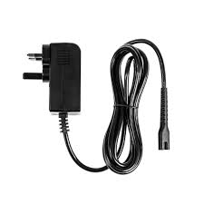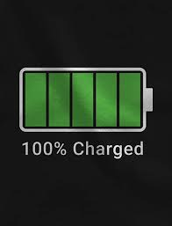

# 

# **Resources**

**Various careers/results day information:**

* [Tower Hamlets Young WorkPath website](http://www.towerhamlets.gov.uk/youngworkpath)
* [Ofqual website](http://www.gov.uk/government/organisations/ofqual)
* [UCAS website](http://www.ucas.com/)
* National Careers Service (lines are open from 08:00 to 20:00 Monday to Friday and 10:00 to 17:00 on Saturdays) [Careers helpline for teenagers](http://www.gov.uk/careers-helpline-for-teenagers).
* National Careers Service course search [National Careers Service course search](https://nationalcareers.service.gov.uk/find-a-course/search) (make sure you select the appropriate options)
* [BBC Bitesize website](http://www.bbc.co.uk/bitesize/articles/z999r2p)
* [Prospects – results day website](https://www.prospects.ac.uk/applying-for-university/getting-into-university/what-to-do-on-a-level-results-day)
* [The Uni Guide website](https://www.theuniguide.co.uk/advice/clearing-results-day/a-level-results-day-grades-what-to-expect)

**A few links for apprenticeships and jobs (check company website/s directly):**

* [Young WorkPath apprenticeship websites](http://www.towerhamlets.gov.uk/lgnl/jobs_and_careers/employment_and_training_initia/Workpath/Young-workpath/Young-Workpath-Apprenticeships.aspx)
* [WorkPath (for Tower Hamlets residents only) website](http://www.towerhamlets.gov.uk/workpath)
* [Apprenticeships website](http://www.apprenticeships.gov.uk/)
* [Gov.UK Apply Apprenticeship website](http://www.gov.uk/apply-apprenticeship)
* [Not Going to Uni website](http://www.notgoingtouni.co.uk/)
* [UCAS Searchjobs website](https://careerfinder.ucas.com/searchjobs/)
* [Indeed website](http://www.indeed.co.uk/)
* [All About School Leavers website](http://www.allaboutschoolleavers.co.uk/)
* [Get My First Job website](http://www.getmyfirstjob.co.uk/)
* [Student Job website](https://www.studentjob.co.uk/part-time-job/london)
* [Jobs Retail website](http://www.jobsretail.co.uk/)

**Taking a gap year**

* [UCAS Gap Year information](https://www.ucas.com/discover/gap-years)
* [National Careers Service Gap Year information](https://nationalcareers.service.gov.uk/careers-advice/advice-on-a-gap-year)
* [Year Out Group website](http://www.yearoutgroup.org/) - association for over 30 gap year organisations
* [Year in Industry STEM placements website](https://www.etrust.org.uk/programmes-platinum-placements)

**Studying abroad**

* [Top Universities website](http://www.topuniversities.com/)
* [Advice on studying in the USA website](http://www.fulbright.org.uk/)
* [Opportunities to study in Europe website](http://www.britishcouncil.org/erasmus)